## PRELAB!

## Read the entire lab, and complete the prelab questions (Q1-Q4) on the answer sheet before coming to the laboratory.

## 1.0 Objective

In Lab 05, we created a circuit to display a 4-bit digital input (set on a set of toggle switches) onto a 7-segment display. In this lab we will perform addition of two 4-bit binary inputs and display the answer in decimal onto two 7-segment displays. *(NOTE: All binary numbers in this lab are in unsigned representation.)*

## 2.0 Setup

Refer to **Figure 1**. We will use the inputs in ModelSim to provide two 4-bit inputs. Each set of four switches represents one binary number. The inputs are wired to a block that adds the two numbers together. The result is processed to convert the results into two decimal digits (binary coded decimal or BCD representation is used for this purpose). For example, if we add number 7 (binary 0111) and number 5 (binary 0101), the result is 12, and it is displayed as two decimal digits, 1 and 2, after converting the result into two decimal digits each in binary, using the module **bcd_converter** block. The two decimal digits are fed to their respective 7-segment display. The two 4-bit inputs are also displayed using two 7-segment displays.

*NOTE: Read through the rest of the document before wiring a circuit like* ***Figure 1.*** *There are instructions below that will save you lots of time.*

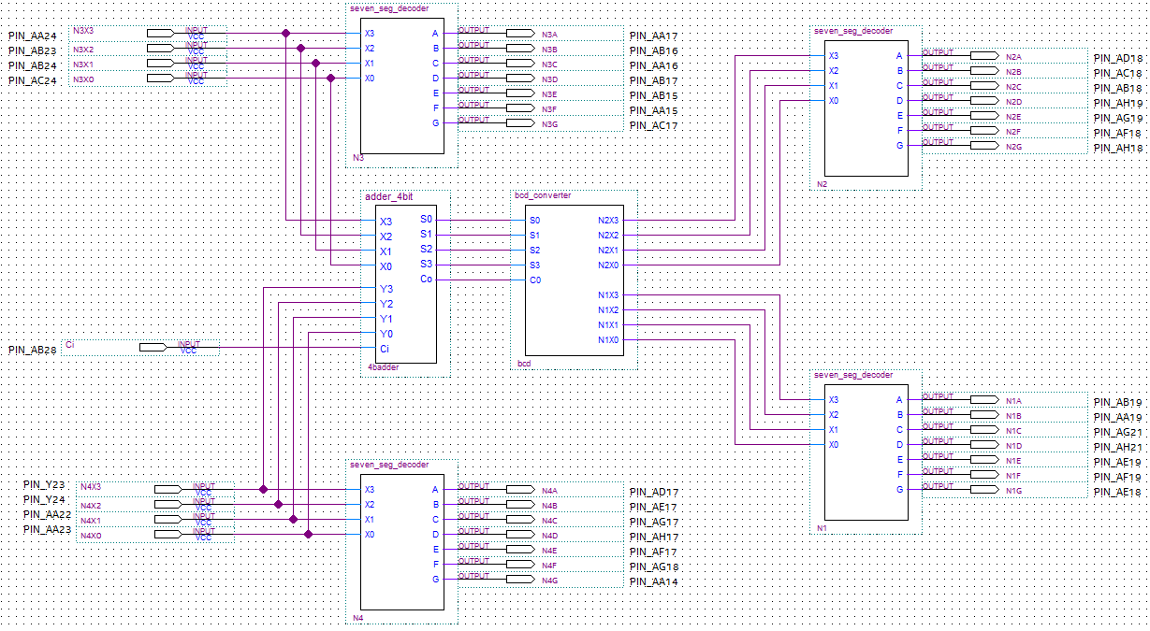

**Figure 1: Adder with BCD Display**

## 3.0 The Design

**3.1 The 7-Segment Code Converter (seven_seg_decoder)**

Use the 4-bit input 7-bit output seven segment decoder from Lab05 to display the 4-bit number onto a 7-segment display. Copy the *.bsf* and *.v* files for the symbol you want to use into your project folder.

**3.2 The 4-bit Adder**

In this lab, you will use a 4-bit adder that you have not implemented yet, but it is provided to you. Download *full_adder.bdf* and *adder_4bit.bdf*, as well as their respective *.bsf* files, to your Lab06 directory from the files provided in your lab assignment folder. The full adderis used by the 4-bit adder to do the addition. The function of this block is to add two 4-bit numbers. Its output is a 4-bit number and a “carry-out bit” *C0*, or, in other words, a five-bit number.

**3.3 Binary Coded Decimal Converter**

This block converts the adder output into two decimal digits, each of which is represented using 4-bits, and thus produces eight outputs for the two 7-segment displays. Here, for example, the output N2X0 is the least significant bit (X0) of the tens-place digit (N2) of the output, and {N2X3 N2X2 N2X1 N2X0} correspond to the four bits that represent this tens-place digit. This block is created using Verilog as part of *Prelab Q4*.

**3.4 Test the BCD Adder**

Perform the additions you carried out in the prelab to test your circuit. Include your design to your answer sheet.

# 

# 5.0 Complete

You are done with this lab. Ensure that all files are closed and then exit Quartus Prime. Log off the computer, and submit your answer sheet. **Don’t forget to write down your name and your lab section number**.